**Introduction to Power BI – 21 May 2025**

Agenda

1. **Access / Navigation:** Understanding how to navigate through the Power BI interface to access various features and functionalities.
2. **Exporting data:** How to export data from Power BI to other formats for further analysis or sharing.
3. **Filters:** Using filters to refine and focus on specific data within reports.
4. **Bookmarks:** Creating and using bookmarks to save specific report views for easy access and presentation.
5. **Explore:** exploring data in depth to uncover insights and trends.
6. **Charts:** Explore four pre set chart options available on each Power BI report
7. **Meeting notes & actions.**

OR three dots, right mouse click to access option to copy image with caption

**CHARTS**

FRIC claims overview report. Left hand side bar 4 charts available with the ability to change the X and Y axes or click into a chart bar to see data :

* Defaults to claims by authority

Left hand side bar

Analysis selectors for X and Y values

Radial button – select one option only

Box button – multi select option, ctrl + left mouse click

Right mouse click on chart bar for additional options.

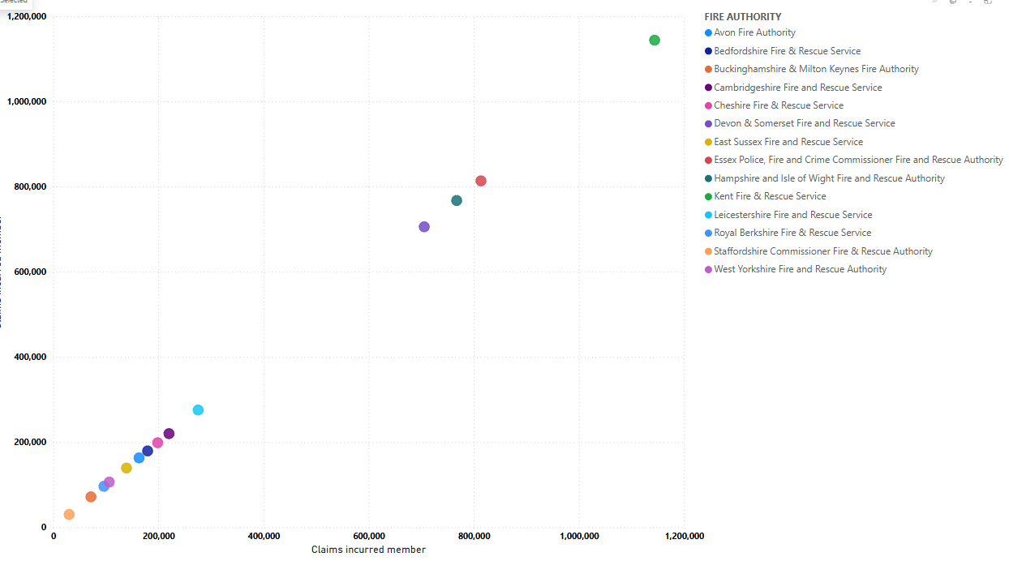

Scatter plot

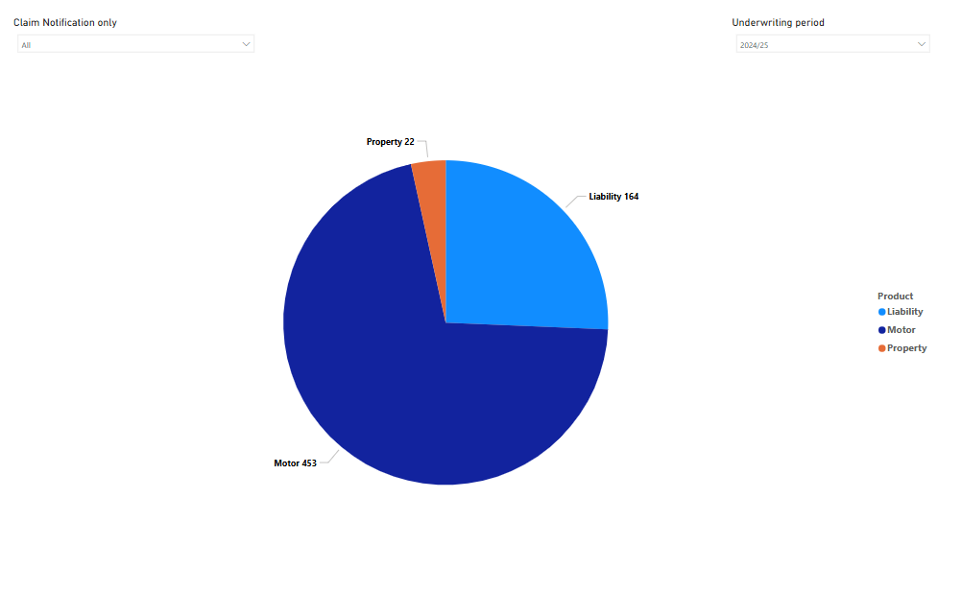

Pie Chart

Claims 2D chart

**Meeting notes**

**Introduction to Power BI:**Introduction session on Power BI, with Nic Warmink and Mark Miles from Thomas Miller. The session aimed to cover basic navigation, exporting data, using filters, bookmarking, and utilising graphs.

**Navigation in Power BI:**Explanation of the navigation steps in Power BI, including the sidebar for claims information analysis, the top menu for downloading and embedding reports, and the right-hand menu for resetting filters, adding bookmarks, expanding page size, refreshing data, and adding comments.

**Exporting Data:**Demonstration ofhow to export data from Power BI into an Excel file, explaining the steps to access the export data function and download the report.

**Applying Filters:**Demonstration of how to apply filters in Power BI, using the hover menu and the right-hand sidebar to select specific filters such as authority and status.

**Creating Bookmarks:**how to create personal bookmarks in Power BI to save filtered reports for easy access in the future.

**Exploring Data:**Introduction tothe explore option in Power BI, which allows for in-depth analysis using attributes and creating visual representations such as pivot tables and charts.

**Nic Warmink:**Top tip **-** the importance of clearing filters to avoid incorrect data and demonstrating how to create graphs and analyse claims data using various filters.

**Using Graphs:**Explanation of how to use different graphs in Power BI to analyse claims data, including claims count, outstanding claims, and claims by authority.

**Notes Page:**Notes page, which provides explanations of the information on each report.

**Member Reports:**Discussion around the development of dedicated member reports in Power BI, which would default to the member's data and provide customised information.

**Actions:**

**Future Sessions:**attendees agreed to another meeting in one months time to further explore Power BI and provide additional training and support.

**Feedback and Requests:**Sue encouraged participants to send their queries and requests for information or reports to the info at fric mailbox [info@fric.org.uk] for coordinated support.

**Access to KPI Report:**Sue highlighted the importance of the KPI report for quarterly senior management reports and mentioned the need to develop a version for all members.

**Frequently Asked Questions:**Sue and Mark discussed the availability of a frequently asked questions report in Power BI and the need to ensure all members have access to it.

**Development of Power BI:**Sue and Nic mentioned ongoing development in Power BI, including the creation of dedicated member reports and the improvement of response times for queries.

**Data refresh frequency:** Claims data uploaded overnight, financials uploaded within 10 days from the end of the previous month.

**Follow-up tasks**

1. **Next Session:**Schedule another Power BI session in four weeks. (Sue)
2. **Documentation Update:**Add screen snips and information from Nic's demonstration to the Word document and upload it to Huddle. (Sue)
3. **KPI Report Access:**Discuss with Paul the timeline for releasing the new KPI report to members. (Sue, Mark)
4. **FAQ Report Access:**Verify access to the FAQ report and ensure all members can view it. (Sue, Mark)
5. **Member Reports:**Send any requests for information or reports to info@fric.org.uk for coordination. (All Members)
6. **Power BI Feedback:**Provide feedback on what members would like to see in Power BI and any specific reports needed. (All Members)
7. **Monthly Data Refresh:**Confirm the process and timeline for monthly data refresh in Power BI, similar to QlikSense. (Nic)